**DevOps Assignment -1**

**1)Explain importance of Agile software development**.

**Ans)**

**Agile software development**

Agile methodologies break development into smaller, manageable units called "iterations" or "sprints." Each sprint involves planning, development, testing, and review, allowing teams to adapt to changes quickly and deliver functional software frequently. This approach enables faster delivery, higher quality, and improved responsiveness to customer needs.

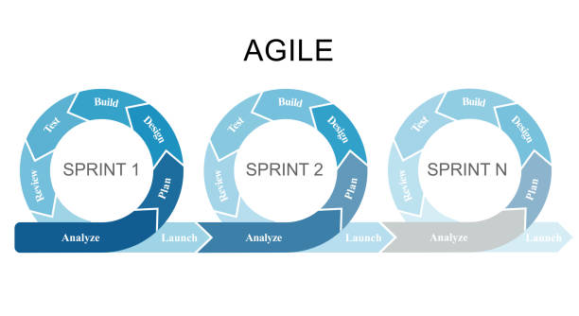

Agile software development is important for several reasons, and it has become the preferred methodology for many teams and organizations. Here's why it's significant:

1. **Flexibility and Adaptability**: Agile embraces change, which is essential in today's fast-paced technological environment. It allows teams to adapt to changing requirements, whether due to customer feedback or market shifts. This is especially valuable when working on long-term projects where initial assumptions may no longer be valid.
2. **Faster Delivery**: Agile promotes the concept of delivering work in small, incremental pieces (often called sprints), which results in faster delivery of functional software. This allows businesses to release products quicker and gather user feedback earlier in the development process.
3. **Improved Collaboration**: Agile emphasizes collaboration between developers, stakeholders, and customers. Regular meetings like stand-ups and sprint reviews ensure that everyone is aligned on progress, issues, and priorities. This continuous communication helps prevent misunderstandings and fosters teamwork.
4. **Customer-Centric**: Agile focuses on delivering value to customers and ensuring that the product meets their needs. By involving customers early and frequently throughout the development process (such as through demos and feedback loops), teams can make sure the product is on track to meet user expectations.
5. **Quality Improvement**: Continuous testing and integration in Agile help detect issues early in the development process. With frequent releases and iterations, quality is consistently improved upon as teams can identify and address bugs and other problems in smaller, more manageable pieces.
6. **Risk Reduction**: By working in small, iterative cycles, teams can identify and address potential risks early in the project. This proactive approach helps reduce the likelihood of major failures and costly delays later on.
7. **Increased Transparency**: Agile’s emphasis on regular meetings and clear documentation ensures that everyone, from developers to project stakeholders, is kept in the loop about progress and challenges. This transparency leads to better decision-making and greater accountability.
8. **Higher Engagement and Motivation**: Agile promotes autonomy, empowering teams to make decisions about how they work. This sense of ownership can increase motivation and lead to higher morale among team members.
9. **Continuous Improvement**: Agile promotes a culture of continuous improvement. At the end of each sprint, teams conduct retrospectives to discuss what went well, what could be improved, and how they can adjust their processes for the next iteration.

Agile helps organizations remain competitive, adaptable, and customer-focused while maintaining quality and efficiency in their software development process.

**2) Explain DevOps architecture and its features with a neat sketch.**

**Ans:**

**DevOps Architecture:**

DevOps (Development and Operations) is a set of practices and tools that aim to integrate and automate the work of software development (Dev) and IT operations (Ops) to improve the efficiency of the development and delivery pipeline. The goal is to reduce the time between writing code and deploying it to production, while maintaining high quality

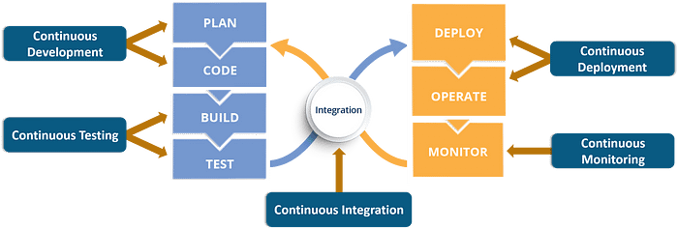

**DevOps Architecture Diagram:**

**1. Plan**

* Define project goals, requirements, and roadmaps.
* Use Agile methodologies for sprint planning and backlog management.

**2. Code**

* Write, review, and manage source code using version control.
* Follow best practices like code versioning and branching strategies.

**3. Build**

* Compile the source code and resolve dependencies.
* Automate builds to ensure consistency and efficiency.

**4. Test**

* Perform automated and manual testing for quality assurance.
* Identify bugs early with unit, integration, and performance testing.

**5. Deploy**

* Use CI/CD pipelines for automated and reliable deployments.
* Ensure smooth rollbacks and version control for stability.

**6. Operate**

* Manage infrastructure and application runtime in production.
* Use Infrastructure as Code (IaC) for efficient scaling and provisioning.

**7. Monitor**

* Continuously track system performance, logs, and security metrics.
* Use monitoring tools to detect and resolve issues proactively.

**DevOps Architecture Features:**

1. **Collaboration**: DevOps emphasizes close collaboration between development, operations, and other stakeholders (like QA and security). This ensures better communication and shared goals.
2. **Continuous Integration (CI)**: Developers continuously integrate their code changes into a shared repository. Automated tests are run to verify that new code does not break existing functionality.
3. **Continuous Delivery (CD)**: Once the code is integrated, it is automatically prepared for release to production. This ensures that the software is always in a deployable state, allowing for frequent and reliable releases.
4. **Automation**: A key feature of DevOps is automation of manual tasks. This includes automated testing, deployments, provisioning of infrastructure, and monitoring.
5. **Monitoring and Logging**: DevOps emphasizes the continuous monitoring of the system and logging to quickly identify issues. These insights help in making real-time adjustments to the system.
6. **Infrastructure as Code (IaC)**: DevOps architecture involves using code to define and manage infrastructure, enabling automated provisioning, configuration, and management of environments.
7. **Feedback Loops**: DevOps relies on fast and continuous feedback between teams (development, operations, testing, etc.) to improve software quality and delivery speed.

**3) Describe various features and capabilities in agile.**

**Ans:**

Agile software development is a flexible and adaptive approach to delivering high-quality software. Its core features and capabilities are designed to help teams respond effectively to changes, deliver continuous value to customers, and maintain efficient workflows.

**Key Features and Capabilities of Agile:**

1. **Iterative Development**:
   * **Feature**: Agile follows an iterative approach, where work is divided into smaller chunks called **sprints** (usually 1-4 weeks).
   * **Capability**: This enables teams to build software incrementally, delivering working software regularly and adjusting to new requirements based on feedback after each iteration.
2. **Customer Collaboration**:
   * **Feature**: Agile emphasizes constant collaboration with the customer or end-users throughout the development process.
   * **Capability**: Feedback from customers is gathered regularly, ensuring that the product aligns with their needs and expectations. This helps in delivering software that truly adds value.
3. **Flexibility and Adaptability**:
   * **Feature**: Agile welcomes change, even late in development. As business needs evolve, Agile teams can adapt their approach and prioritize different tasks or features.
   * **Capability**: This flexibility ensures that the final product meets current market demands and keeps pace with changing customer requirements.
4. **Self-Organizing Teams**:
   * **Feature**: Agile teams are typically **self-organizing**, meaning they have the autonomy to decide how best to approach tasks and solve problems.
   * **Capability**: This autonomy empowers teams to make decisions quickly, fosters creativity, and builds a sense of ownership, leading to more motivated and productive teams.
5. **Continuous Delivery**:
   * **Feature**: Agile focuses on **delivering small, incremental updates** frequently.
   * **Capability**: By ensuring continuous delivery of working features, teams can release new versions faster, improving time-to-market and reducing risk by having small, manageable updates instead of large, complex releases.
6. **Cross-Functional Teams**:
   * **Feature**: Agile promotes teams that have all the necessary skills for development, testing, deployment, and maintenance. These are known as **cross-functional teams**.
   * **Capability**: This enables faster decision-making and problem-solving since every team member has a broad skill set, and communication is streamlined across different roles.
7. **Transparency**:
   * **Feature**: Agile provides high visibility into the development process, often through tools like **task boards**, **burndown charts**, and **status meetings**.
   * **Capability**: Transparency fosters trust among team members and stakeholders, as progress, challenges, and any changes in scope are clearly visible. This ensures that everyone is on the same page.
8. **Frequent Testing and Quality Assurance**:
   * **Feature**: Agile incorporates **continuous testing** throughout the development cycle.
   * **Capability**: Automated tests and regular manual testing ensure that the software is of high quality at each stage. Problems are identified and fixed early, improving software reliability and reducing defects.
9. **Short Feedback Loops**:
   * **Feature**: Short iterations and frequent feedback loops are fundamental to Agile.
   * **Capability**: This capability enables teams to assess progress frequently, adjust features based on immediate feedback, and continuously improve the product. This quick feedback mechanism enhances collaboration between developers, testers, and stakeholders.
10. **Prioritization of Features**:
    * **Feature**: Agile methodologies often use techniques like **user stories**, **backlogs**, and **sprints** to prioritize features based on business value.
    * **Capability**: Teams can focus on delivering the most important features first, ensuring that the most valuable functionality is available to customers early on, while less critical features are developed later.
11. **Simplicity**:
    * **Feature**: Agile encourages **simplicity**—to maximize the amount of work not done.
    * **Capability**: Teams focus on delivering only what is necessary and eliminating unnecessary complexity, reducing overhead, and increasing development speed.

.

**1). What is SDLC? Explain various phases involved in SDLC.**

Ans:

**SDLC (Software Development Life Cycle)** is a systematic process used to design, develop, test, and maintain software efficiently. It provides a structured approach to software development, ensuring high-quality and cost-effective software solutions.

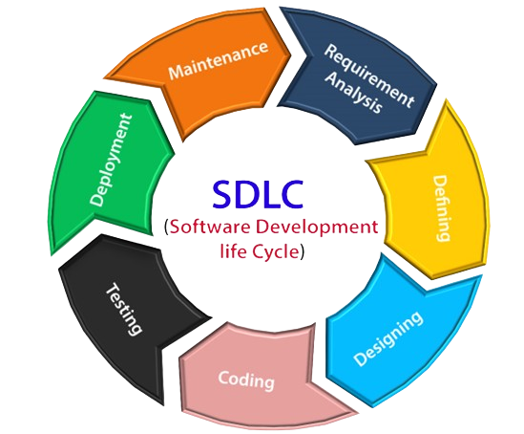

**Phases of SDLC:**

#### ****1. Planning****

This phase involves defining the project scope, goals, and feasibility. It includes risk assessment, resource allocation, budgeting, and creating a roadmap for development. A well-structured plan helps ensure smooth execution.

#### ****2. Requirement Analysis****

In this phase, developers gather and analyze user and business requirements. The functional and non-functional requirements are documented in an SRS (Software Requirement Specification), which serves as a reference for the development team.

#### ****3. Design****

The system architecture, database structure, and user interface are designed based on the requirements. This phase defines how different components of the software will interact and ensures scalability and performance.

#### ****4. Development (Implementation)****

The actual coding takes place in this phase. Developers write code based on the design specifications using programming languages and frameworks. Version control systems like Git help manage code efficiently.

#### ****5. Testing****

The software undergoes various tests, including unit testing, integration testing, and security testing, to identify and fix bugs. This phase ensures the software functions correctly and meets quality standards.

#### ****6. Deployment****

The tested software is deployed to a live environment or production server. Deployment can be done manually or through automated CI/CD pipelines, ensuring a smooth release.

#### ****7. Maintenance & Support****

After deployment, the software is monitored for issues, bugs, and performance. Updates, patches, and new features are implemented to enhance functionality and security.

**2. Explain briefly about various stages involved in the DevOps pipeline.**

Ans:

### ****DevOps****

**DevOps** is a set of practices, tools, and cultural philosophies that integrate **development (Dev)** and **operations (Ops)** teams to enhance collaboration, automation, and efficiency in software delivery. It focuses on continuous integration, continuous deployment (CI/CD), and infrastructure automation to ensure faster, more reliable software releases.

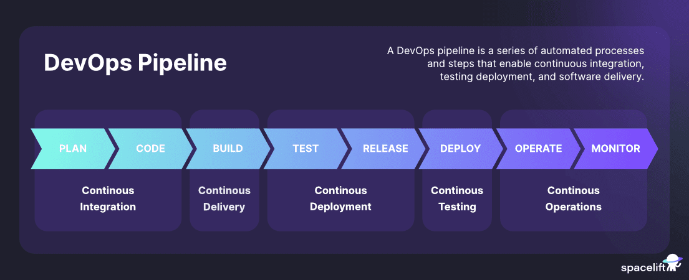

### ****Stages of a DevOps Pipeline****

A **DevOps pipeline** automates software development, testing, deployment, and monitoring to ensure faster and more reliable delivery. It consists of several key stages:

#### ****1. Plan****

This stage involves defining project goals, requirements, and workflows. Teams use Agile methodologies to manage tasks, track progress, and collaborate efficiently.

#### ****2. Develop****

Developers write, review, and manage code using version control systems like Git. Branching strategies and automated code reviews ensure code quality and collaboration.

#### ****3. Build****

Source code is compiled, dependencies are resolved, and executable artifacts are generated. Automated build tools like Maven, Gradle, or Jenkins streamline this process.

#### ****4. Test****

Automated and manual testing ensures code functionality, security, and performance. Various tests like unit, integration, and security testing are performed using tools like Selenium and JUnit.

#### ****5. Release****

The tested and verified software is prepared for deployment. CI/CD pipelines automate this process, ensuring smooth transitions between environments.

#### ****6. Deploy****

The software is deployed to staging or production environments. Containerization (Docker, Kubernetes) and Infrastructure as Code (Terraform, Ansible) help manage deployments efficiently.

#### ****7. Operate****

This phase focuses on managing and optimizing the software in production. Configuration management and incident handling ensure reliability.

#### ****8. Monitor****

Continuous monitoring helps track application performance, security, and system health. Tools like Prometheus, Grafana, and ELK Stack detect issues early for quick resolution.

**3. Describe the phases in DevOps life cycle.**

**Ans)**

DevOps is a software development approach that emphasizes collaboration between development (Dev) and IT operations (Ops) to enable faster and more reliable software delivery. The DevOps life cycle consists of several phases that work in a continuous loop to ensure smooth development, deployment, and maintenance of applications.

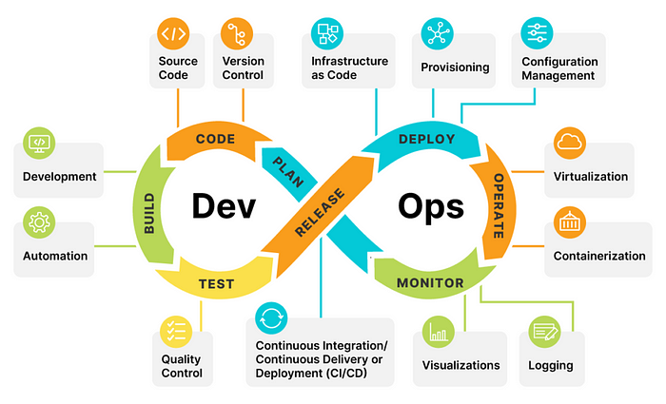

**Phases in the DevOps Life Cycle**

**1. Plan**

This is the initial phase where teams define the project scope, objectives, and requirements. It involves brainstorming, strategizing, and documenting the development process. Agile methodologies, such as Scrum or Kanban, are often used to improve collaboration and efficiency.

* **Tools:** Jira, Confluence, Trello

**2. Develop**

In this phase, developers write, review, and manage code. They use version control systems to track changes and collaborate effectively. Continuous Integration (CI) ensures that code changes are frequently merged and tested.

* **Tools:** Git, GitHub, GitLab, Bitbucket

**3. Build**

Once the code is developed, it is compiled into executable artifacts. Dependency management and package creation are handled in this phase. Automated builds help streamline the process.

* **Tools:** Maven, Gradle, Jenkins

**4. Test**

Testing is a crucial phase to ensure that the code is bug-free and meets quality standards. Automated and manual testing methods, including unit tests, integration tests, and security tests, are implemented.

* **Tools:** Selenium, JUnit, Jest, Postman

**5. Release**

In this phase, the application is prepared for deployment. Release management strategies such as versioning, rollback plans, and CI/CD pipelines ensure smooth transitions between development and production environments.

* **Tools:** Jenkins, Travis CI, CircleCI

**6. Deploy**

The application is deployed to a live production environment. Automated deployment tools ensure minimal downtime and seamless updates. Strategies like blue-green deployment and canary releases help in risk mitigation.

* **Tools:** Docker, Kubernetes, AWS, Azure, GCP

**7. Operate**

This phase focuses on monitoring and managing the live application to ensure stability, availability, and performance. Logging and monitoring tools help detect and resolve issues proactively.

* **Tools:** Prometheus, Grafana, ELK Stack

**8. Monitor & Feedback**

Continuous monitoring provides insights into application performance and user experience. Feedback from users and system logs helps identify areas for improvement, feeding back into the planning phase for future iterations.

* **Tools:** Splunk, Nagios, Datadog